**Connecting to EC2 instance**

Use case once connected : Download source code, update system packages

ssh -i ./my-key-pair.pem ec2-user@compute.amazonaws.com

ssh - call for ssh command

-i flag to specify where our private key file resides on our machine

default user name connecting on the remote system

after @symbol we specify where we want to connect to which can be ip add of the instance or public dns name

Select Instance and launch  
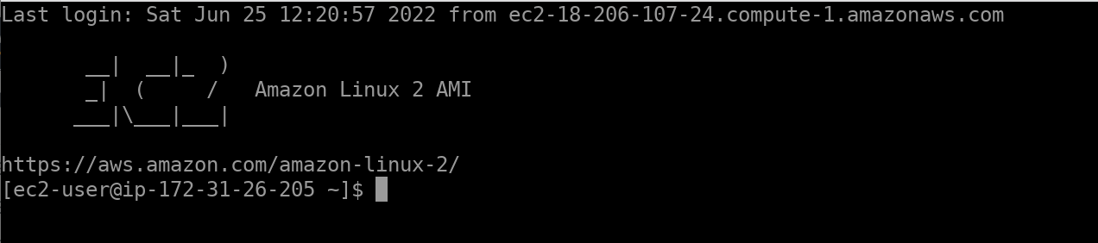

Allowing connections from any source is not a security best practice

Select instance and view security group  
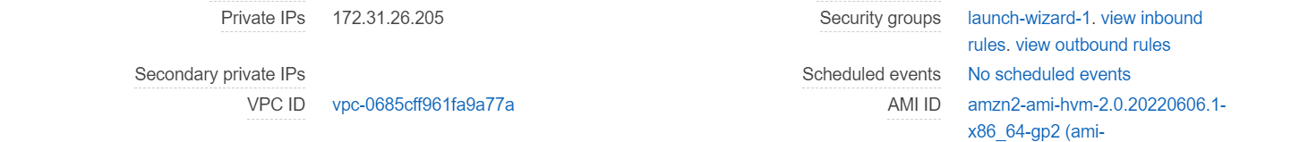

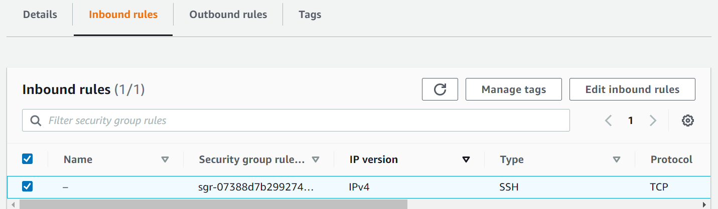

**Transferring files to an EC2 instance**

can be done through secure copy protocol(SCP)

scp -I ./my-key-pair.pem ./MyLocalFile.txt ec2-user@compute.amazonaws.com

Call scp using i flag to specify the location of our private key the files need to have irs permissions properly configured using the cchmod 400 command. specify thepath to our file that we need to transfer to our instance. and user name

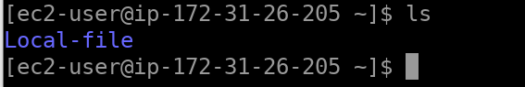

**==================================================================================Storage volume**

* Grant us more storage capacity
* choose from instance store or eBS types
* created through the aws console or CLI
* must be attached and mounted on an instance to be used.

**EBS Vol :** Network-attached storage, automatically replicated with and available zone, can only be attached to one instance at a time. cloudwatch monitoring, amazon ebs encryption.

**Instance store vol :** physically attached disks, vol avail will depend on the instance type, not supported by all EC2 instance types, no cost if it is the root volume

the data on an instance store volume only persists within the lifetime of the instance.

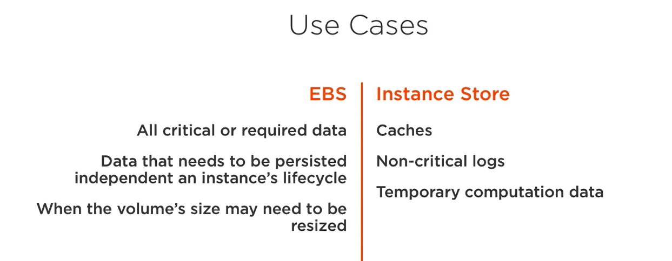

**Add EBS to an instance  
  
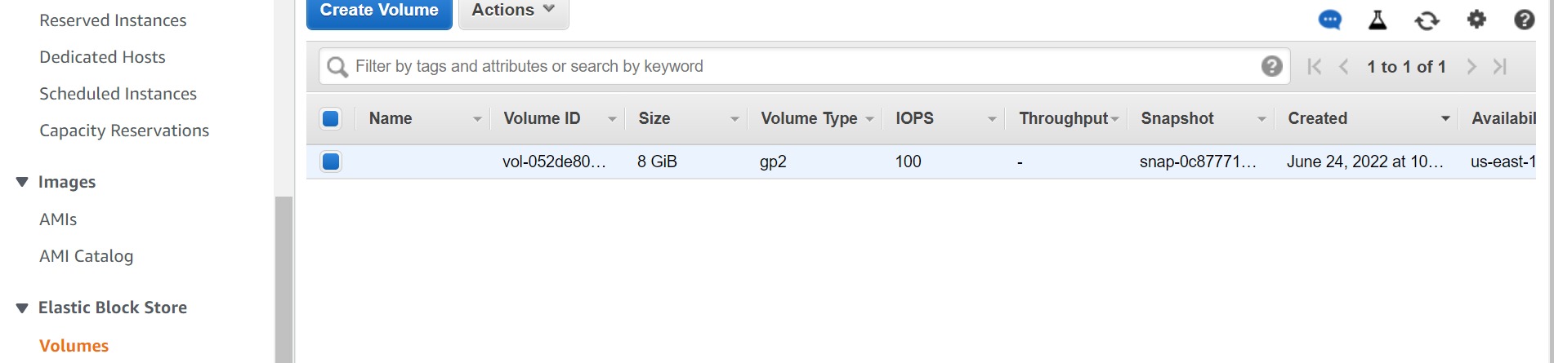**

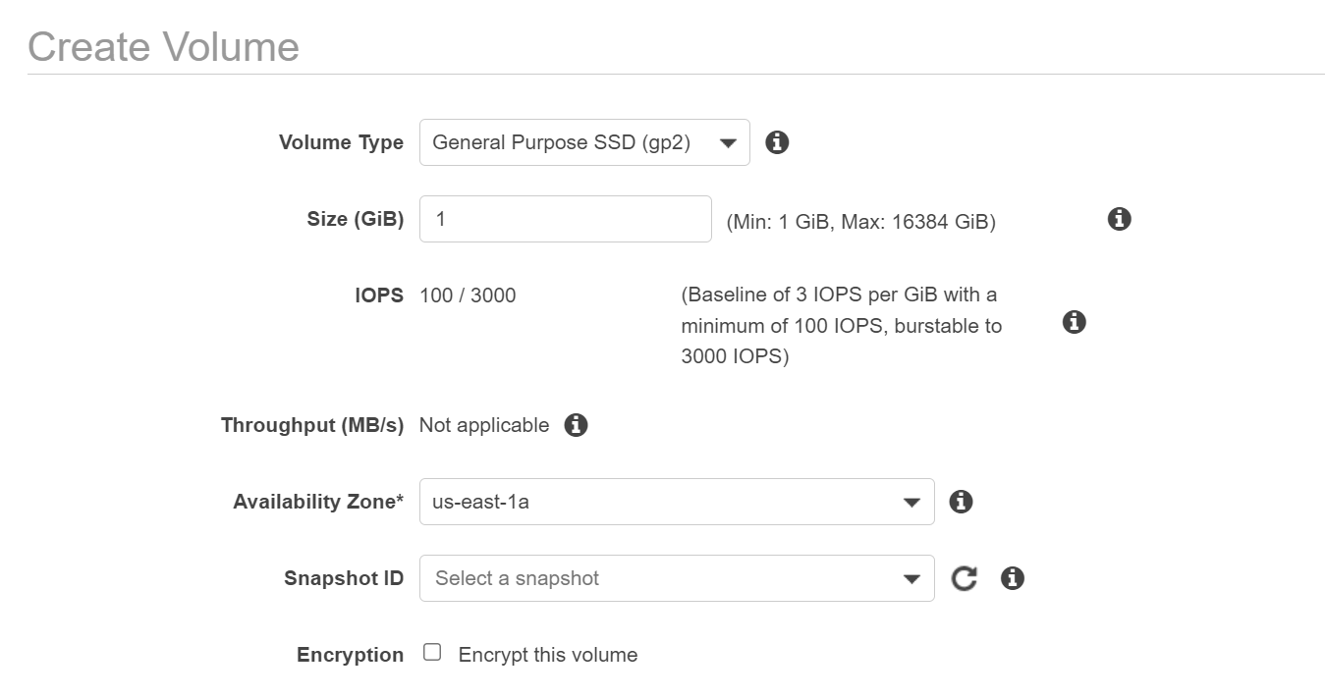

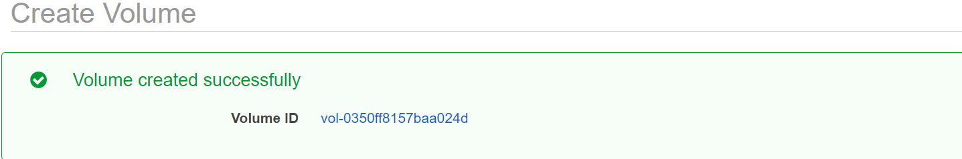

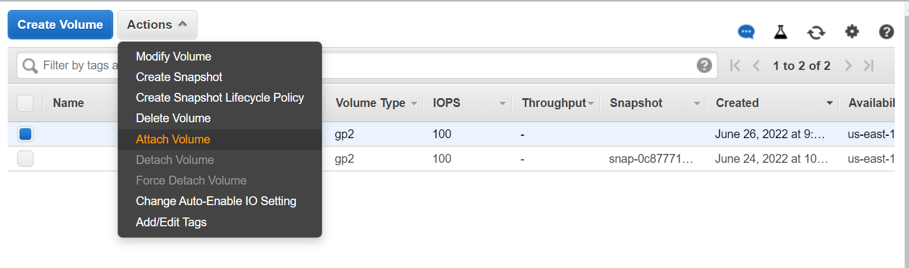

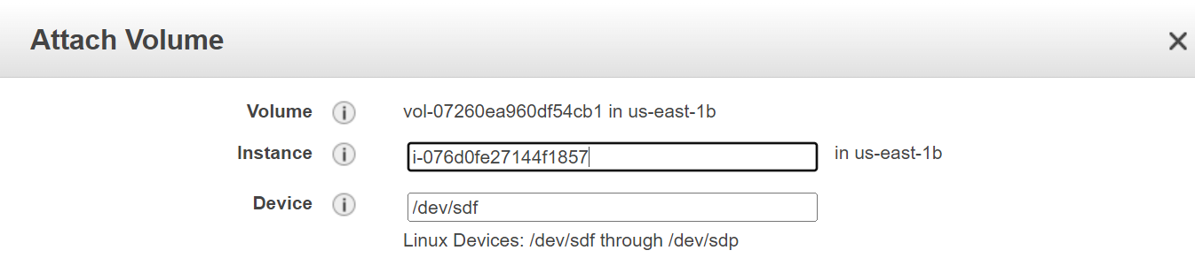

We need to make sure our vol has a filesystem on it.  
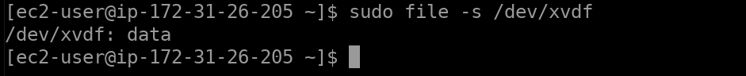

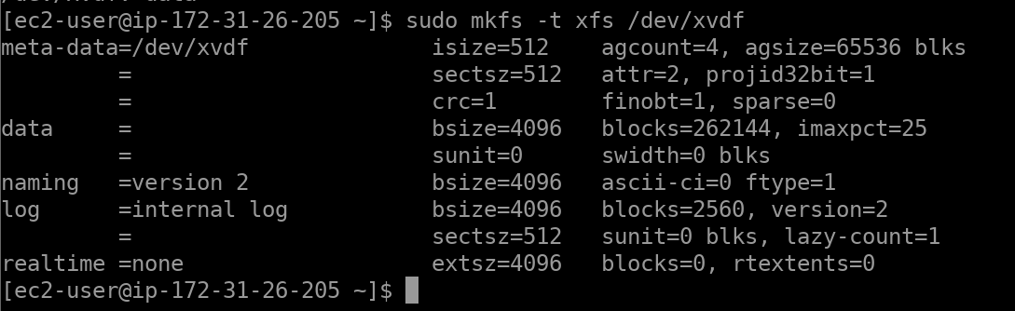



==================================================================================

**Create a mount point for the volume**



**EBS snapshot :** are point in time,subsequent snapshots will only store the blocks that changes, old snapshots can be deleted, charged on a gigabyte-month basis

**Best Practices :** the process is dome asynchromously as the device is still being used. will be pending state unless transferred to s3. Any R/W after initiate wont be included in the snapshot.

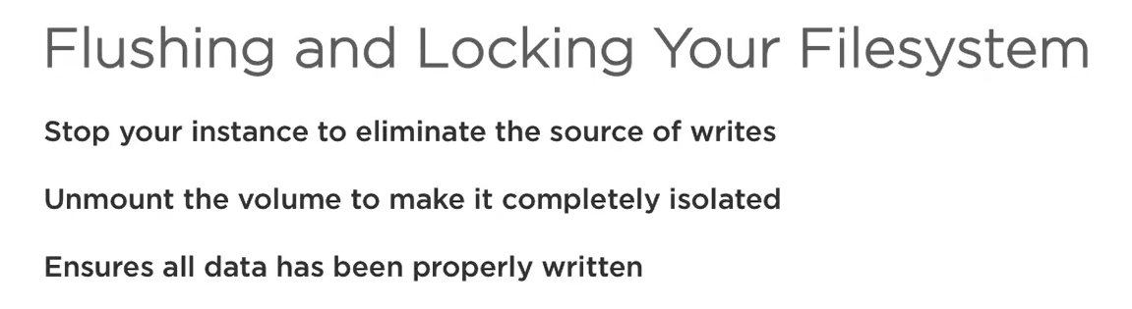

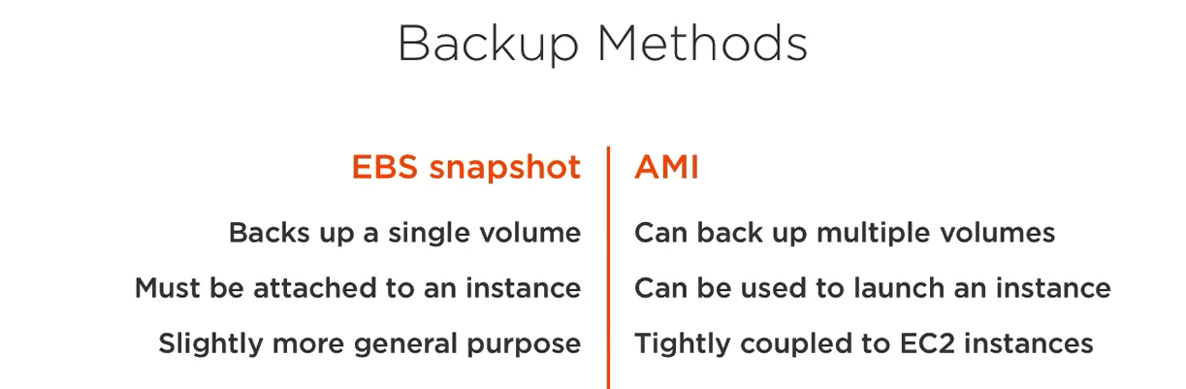

**Creating Snapshots  
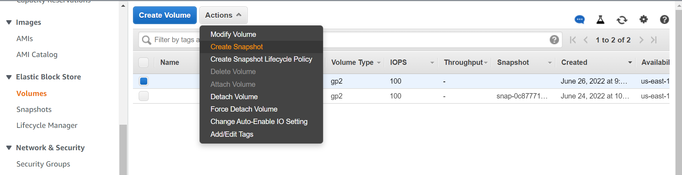**

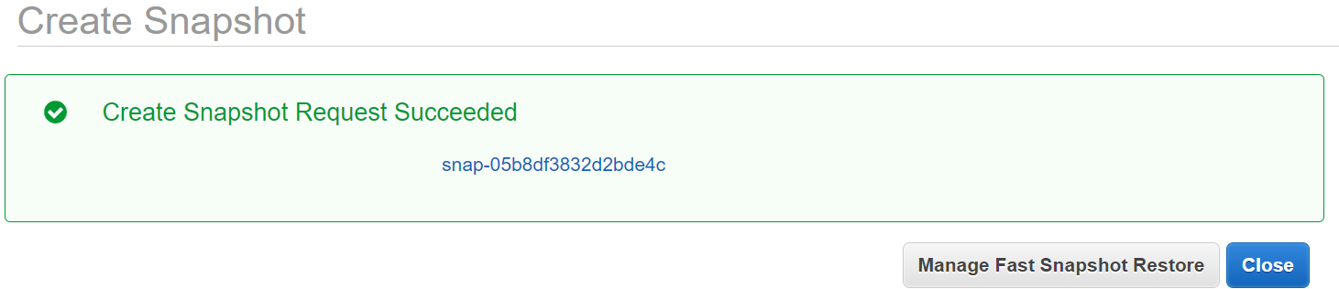

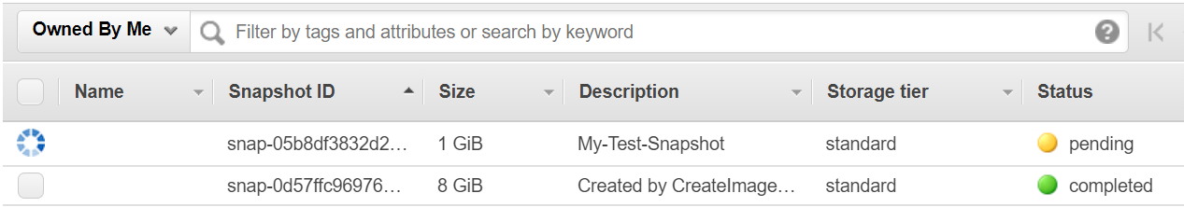

**Restore Backup**

Create Vol using snapshot ID

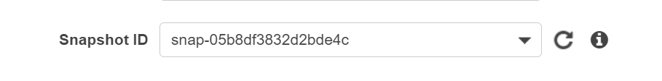

**Managing the EC2 Instance type**

* Instances can be smaller or larger than anticipated
* we may want to upgrade from a previous gen of instance type.
* resize instance to better suit your needs

**Virtualization type**

* Linux AMI can use paravirtual(PV) or hardware virtual machine(VM) for virtualization
* instances must retail their type